
Computer Networks Lab_241L
UW-24-CS-BS-101
Registration NO:
Muhammad Talha_CS.3ndB
Lab Task # 04
UNIVERSITY OF WAH(UOW)

DEPARTMENT OF COMPUTER
SCIENCE

COURSE:

SUBMITTED TO:

Mr. Hassan Shafaqat
SUBMITTED BY:

Task # 2
- Adding Hubs on Screen
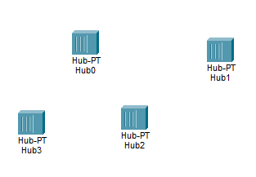
- Adding Computers on screens
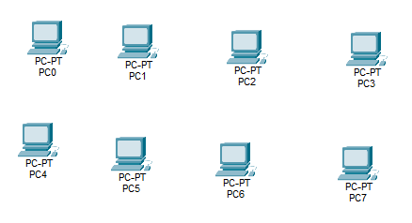
- Arranging all things according to given scenario
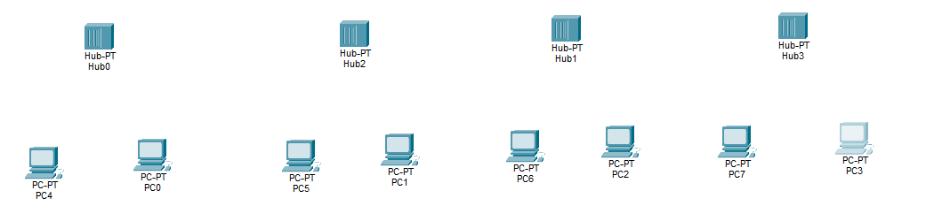
- Connecting through wires between computer to hubs
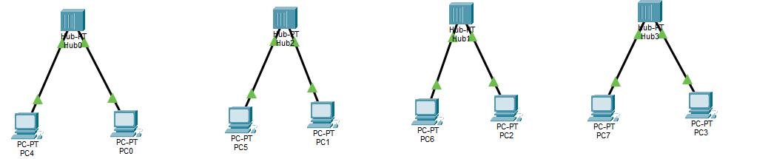
- Connecting through cross wires between hubs

- Assigning/Giving IP addresses to each computers
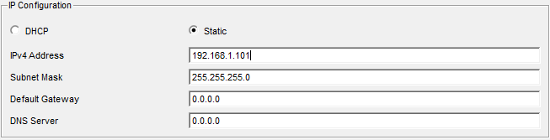
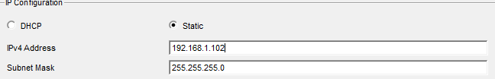
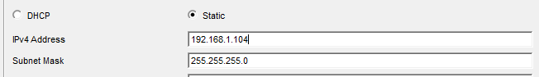
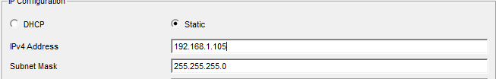
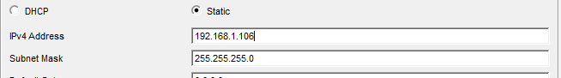
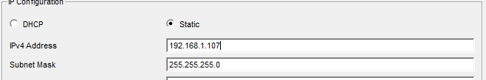
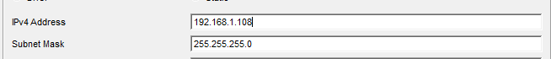

- Adding Comments to each computers

Sending messages from each computer to all computer.

- Computer 1

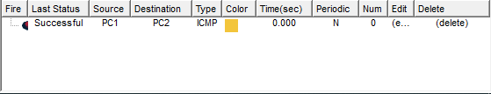
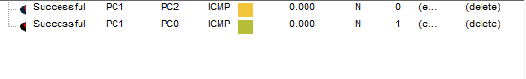

- Computer 2

- Computer 3

- Computer 4
- Computer 5
- Computer 6
- Computer 7

